CSA05-DATABASE MANAGEMENT SYSTEMS
LAB OBSERVATION
EXPERIMENT:01
AIM:
To Create, Alter, Drop, Rename, Truncate using Data Definition Language (DDL) statements.
QUESTION:
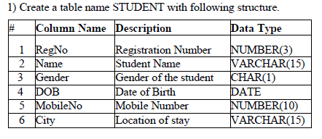
SQL QUERIES:
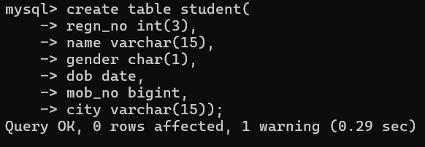
OUTPUT:
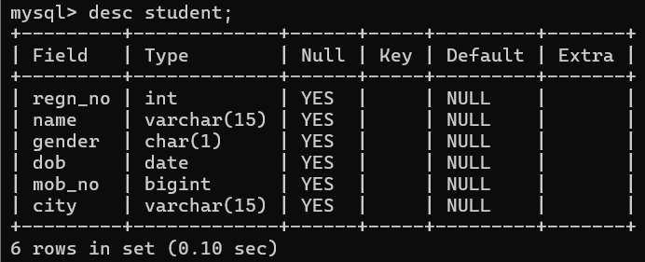
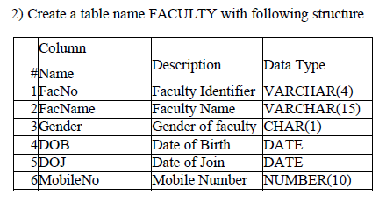
SQL QUERIES:

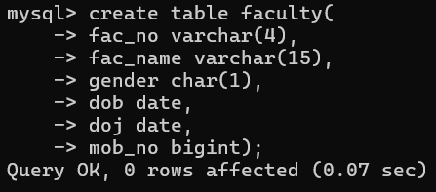
OUTPUT:
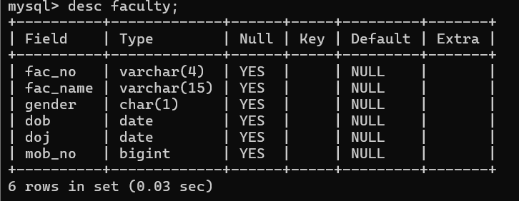

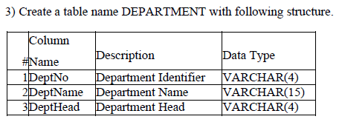
SQL QUERIES:
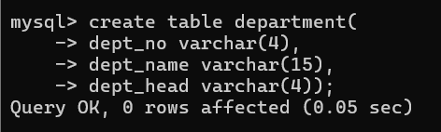
OUTPUT:
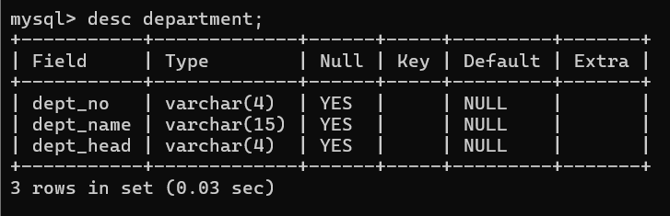

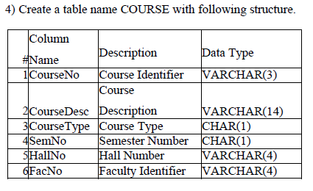
SQL QUERIES:
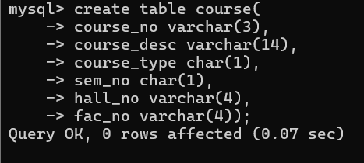
OUTPUT:
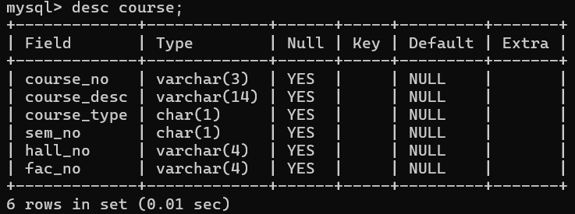
RESULT:
Tables are created, altered and modified using DDL commands.

